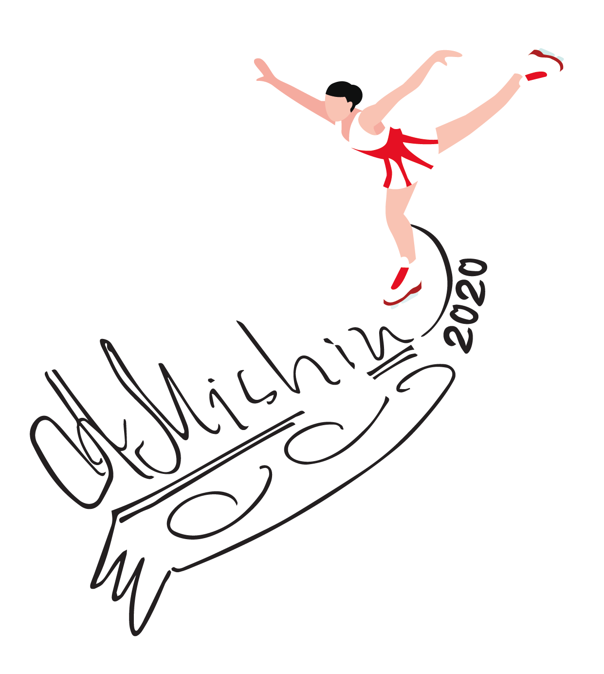

TARTU
5.08-14.08.2020
Skater:

name …………………………………………………………………………..

male ( ) female ( )

date of birth …………………………………………………………………………..

nationality …………………………………………………………………………..

cell-phone …………………………………………………………………………..

e-mail …………………………………………………………………………..

Language  English  Russian  …………….

Parents:

name …………………………………………………………………………..

address
street …………………………………………………………………………..

zip code ………….……………………………………………………………….

city …….……………………………………………………………………..

country ………….………………………………………………………………..

cell-phone ……………….…………………………………………………………..

phone …………..……………………………………………………………….

fax …………………………………………………………………………...

e-mail ……….…………………………………………………………………..

Please mark your skating level
Working on triple jumps
Working on 2 Axel
Working on double jumps
Working on Single jumps and 1 Axel

Skaters
(2 workouts on ice and 2 off-ice workout) without accommodation and meals.

ADDITIONAL PRIVATE LESSONS
Skaters will also be able to take private lessons with all official camp
coaches.

HEALTH & INSURANCE
Medical Insurance
Please note that every skater has to take care about a medical insurance for the period of the camp. This is mandatory!

PAYMENT
CAMP 1200Eur (2 workouts on ice and 2 off-ice workout) without accommodation and meals.

20% after confirmation (by bank transfer) 240 €
80% rest when you arrive (cash) 960 €
An advance payment is required for ensuring a place in the camp.

name accountholder: MTÜ DREAMSPORT
adress of accountholder: Ringtee 75, Tartu
name of the bank:SWEDBANK AS
address of the bank:Liivalaia 8,15040,Tallinn
SWIFT: HABAEE2X (only needed for payments from abroad)
IBAN: EE052200221040500080
Please make sure to mark in the message skaters name and Tartu camp
Please note: no bank costs for the receiver.

GENERAL CONDITIONS
This application does not guarantee the participation to Camp Mishin until we receive advance payment on our bank account. Based on the information received through the application, the organizers will form the training groups. Therefore we ask you to provide accurate information. Changes in the time schedule and groups division can be made only by the coaching staff of the camp. Applicants will receive the detailed time schedule when they arrive.
Camp Mishin reserves the right to make changes to the coaches staff and/or to the course content.
Applying for additional lessons does not automatically guarantee the possibility of having all the requested lessons. Depending on the number of applications, the number of hours reserved for additional lessons can vary.
Depending on the amount of requests, some group lessons may overlap with eventually awarded private lessons. We will do our best to find a replacement possibility for those group lessons, but no guarantee can be offered in such cases.

Participants must provide their own insurance. The organization is not responsible for damages caused by the Camp Mishin participants to a third party. Participants will be responsible for any damage caused to third party and will cover any costs due by the damages caused.

Please provide your own cancellation insurance.

RESPONSIBILITY
We as organizers take not charge of you and your health. We ask all skaters to travel with their parents or a responsible person. If there will happen something to you during practice session we will care about to bring you to doctor or hospital. Out of practice hours it is your personal responsibility. For injuries and illnesses all skaters have to have a health-insurance for the camp.

Signature parents …………………………………………………………………………...

Date……………………………… Place ……………………………………..

